IN 2901- Software Development Project

PROJECT PROPOSAL



Bachelor of Science Honors in Information Technology (BSc Hons (IT)) Faculty of Information Technology
University of Moratuwa

Group Name

Nebula

Project Name

Proactive System Care Monitoring System

Company Name

Virtusa

Mentor Name

Indika Wimalasuriya

Group Members

M.V.S. Gunathilaka
H.M.S.M. Dissanayaka
M.B. Ranasinghe
G.D.D. Wijesinghe
I.P.H.D. Fernando

Supervisor’s name

Ms. Premadasa M G N N

Table of contents

- INTRODUCTION…………………………………………………………...
1.1 Project Title………………………………………………………….......
1.2 Project Overview…………………………………………………….......
1.3 Objectives……………………………………………………………......

- PROJECT SCOPE…………………………………………………………...

- KEY FEATURES……………………………………………………….......

- SUGGESTED TECHNOLOGIES…………………………………………..

- TIMELINE………………………………………………………………….

- REFERENCES……………………………………………………………...

- SIGNATURES OF GROUP MEMBERS…………………………………..

- SUPERVISOR’S DECLARATION………………………………………...

INTRODUCTION

Project Title
Proactive Application Monitoring and Solution Recommendation Platform
An intelligent monitoring and analytics platform designed to proactively detect system anomalies, forecast issues, and generate AI-powered recommendations for resolution. The system helps organizations transition from reactive problem-solving to predictive operations using modern observability data and AI/ML techniques.

Project Overview

Modern enterprise systems are distributed and complex, producing massive amounts of observability data logs, metrics, and traces. Traditional monitoring tools, which rely on manual analysis and static thresholds, fail to detect subtle system degradations or recurring issues early enough.

The Proactive Application Monitoring and Solution Recommendation Platform addresses this challenge by providing an end-to-end AI-driven observability solution. It continuously ingests real-time data from cloud-hosted applications, detects performance and behavioral anomalies, and provides actionable recommendations generated by intelligent algorithms.

The system includes a web-based dashboard for administrators and DevOps teams to visualize performance insights, anomaly trends, and AI recommendations. Alerts are sent via Email or SMS for critical incidents. The platform leverages machine learning models for anomaly detection and natural language processing solution recommendations.

Ultimately, this platform reduces downtime, improves system reliability, and empowers teams to respond faster and more intelligently to potential failures.

Objectives

• Enable Real-Time Monitoring: Continuously collect logs and metrics from multiple applications.
• Detect Anomalies: Use ML models to identify performance, error, and behavioral anomalies automatically.
• Generate AI Recommendations: Suggest possible root causes and corrective actions using NLP-based analysis.
• Provide Visual Insights: Offer an intuitive dashboard with anomaly trends, performance graphs, and incident summaries.
• Enhance Operational Efficiency: Automate alerting and analysis to minimize human intervention.
• Support Role-Based Access: Securely manage access for Admin and viewer roles.
• Optimize System Health: Reduce Mean Time to Detect (MTTD) and Mean Time to Resolve (MTTR)incidents

Key functionalities include,
    - Centralized Application and Log Management
    - Real-Time Anomaly Detection using AI and ML Models
    - AI-Powered Solution Recommendation Engine
    - Interactive Dashboard for Monitoring and Visualization
    - Automated Alerting System via Email and SMS
    - Historical Reporting and Trend Analytics
    - Role-Based User Access and Secure Authentication

PROJECT SCOPE

Users:
    - Administrators and Clients (System Viewers).

Functions:
- Continuous monitoring and analysis of application logs, metrics, and performance data across distributed systems.
- Real-time anomaly detection using AI and ML models such as Isolation Forest, Autoencoder, and LSTM.
- AI-powered recommendation generation for identifying root causes and suggesting corrective actions.
- Interactive dashboard for viewing live system health, anomalies, and performance insights.
- Alert and notification system for critical anomalies through Email and SMS
- Automated reporting and historical analytics for performance trends and system uptime
- Role-based access control for secure user management (Admin, Developer, Viewer)
- Configuration management for defining alert thresholds and retraining AI models.

3.KEY FEATURES

User Management
• Admin can create, edit, and delete users.
• Supports login for Admin, Developer, and Viewer roles.
• Role-based access control for secure data visibility and permissions.

Application and Log Management
• Add and manage applications to be monitored.
• Collect and store logs and performance metrics from each application.
• Enable real-time log filtering, searching, and viewing on the dashboard.

Anomaly Detection Module
• Detect performance, error-rate, and latency anomalies using AI/ML models (Isolation Forest, Autoencoder, LSTM).
• Continuously monitor key metrics such as CPU usage, memory, request latency, and error frequency.
• Classify anomalies by severity level (Low, Medium, High, Critical).

AI Recommendation Engine
• Generate AI-driven solution recommendations for detected anomalies.
• Use NLP to identify probable root causes from log and metric context.

Dashboard and Visualization
• Display real-time system health, anomalies, and recommendations in a single interface.
• Offer interactive charts for performance trends, severity-level filtering, and anomaly timelines.
• Support dark/light modes and responsive layout for accessibility.

Alert and Notification System
• Send automated alerts via Email and SMS for high-severity anomalies.
• Integrate with AWS SNS or Twilio for reliable message delivery.
• Allow configurable alert thresholds and escalation policies per user or application.

Reporting and Analytics
• Generate daily, weekly, or monthly performance and anomaly summary reports.
• Export reports in PDF and CSV formats for audits and management review.
• Visualize historical anomaly patterns and uptime trends.

Security and Access Control
• Implement JWT-based secure authentication for all users.
• Ensure data encryption and access isolation between user roles.
• Support audit logging for user actions and data modifications.

4. SUGGESTED TECHNOLOGIES

Proactive Application Monitoring and Solution Recommendation Platform – Technology Stack

• Frontend Technologies
o Figma for user interface prototyping
o React.js for building the interactive monitoring dashboard
o Chart.js and Material UI for visualization and responsive components

• Backend Technologies
o Node.js (Express) for backend API development and core logic
o Python (Flask/Fast API) for the AI/ML anomaly detection and recommendation services
o RESTful API architecture for communication between modules

• Database
o PostgreSQL for structured storage of logs, metrics, users, and anomaly data
o Redis for caching frequently accessed analytics and recommendations

• AI/ML and Analytics
o Scikit-learn, TensorFlow, and Keras for anomaly detection and forecasting models
o NLP libraries (Hugging Face Transformers) for AI-based recommendation generation
o Pandas and NumPy for preprocessing and statistical analysis

• Authentication & Security
o OAuth 2.0 and JWT for secure authentication and session management
o Role-Based Access Control (RBAC) for Admin, Developer, and Viewer roles
o HTTPS encryption and API key validation for data security

• Notification & Messaging
o AWS Simple Notification Service (SNS) or Twilio for Email/SMS alerts
o SMTP server integration for automated system notifications

• Version Control
o Git and GitHub for source code management and team collaboration

5.TIMELINE

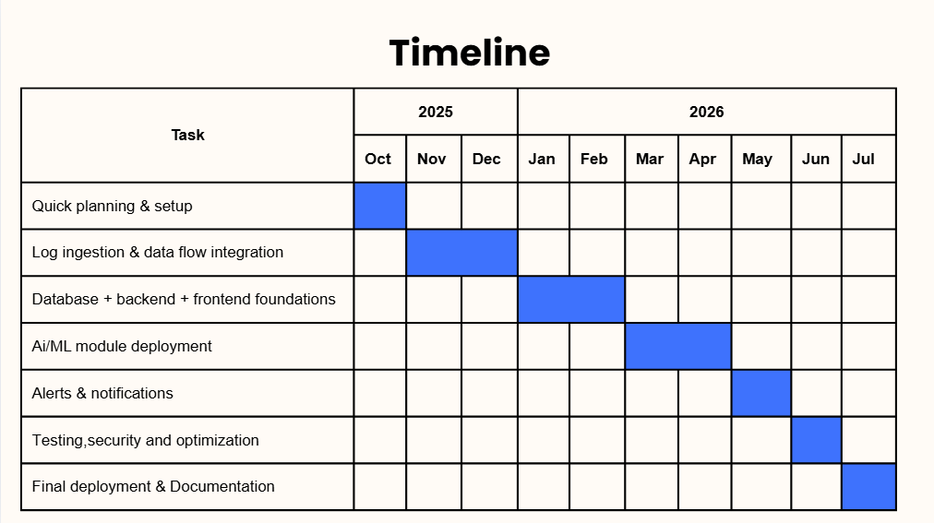

6.REFERENCES

proactive system care monitoring system for AWS deployed applications– Requirement Document

7.SIGNATURES OF GROUP MEMBERS

Name | Index No | Signature
M.V.S. Gunathilaka | 234072H
H.M.S.M. Dissanayaka | 234057R
M.B. Ranasinghe | 234173T | 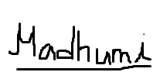
G.D.D. Wijesinghe | 234238A
I.P.H.D. Fernando | 234061A | 

8.SUPERVISOR’S DECLARATION
I hereby declare that I have checked this project, and, in my opinion, this project is adequate in terms of scope and quality.

Name of Supervisor: Ms. M. G. N. N. Premadasa
Designation: Lecturer (Department of Information Technology) Date:
Signature:

